Directions
- Royal Preston Hospital, Physiotherapy Department, Sharoe Green Lane North, Fulwood, Preston, PR2 9HT
- Tel: 01772 716565
- Website: www.lancsteachinghospitals.nhs.uk

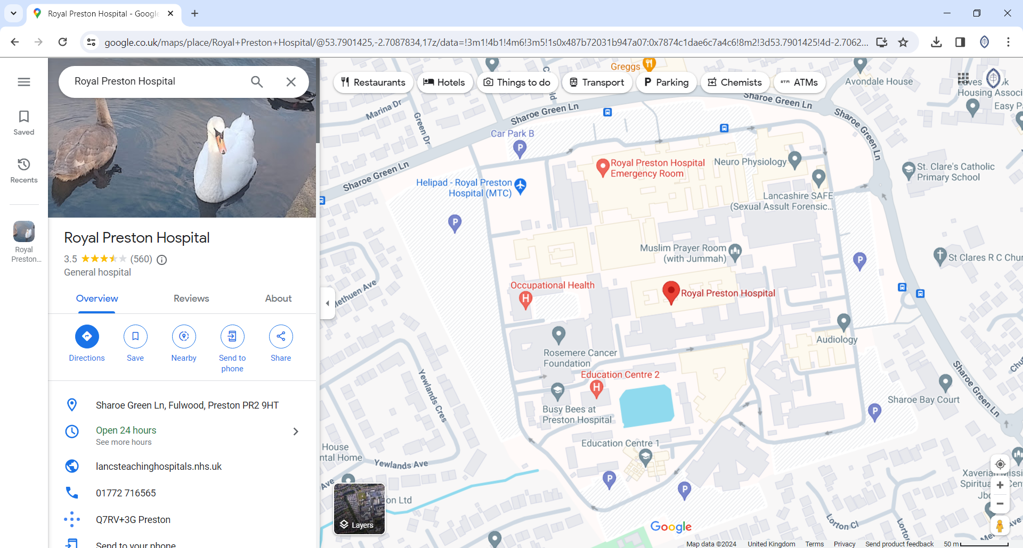

Take junction 32 of the M6.
Turn left off the slip-road onto Garstang Road (A6), heading towards Preston.
At the second major set of traffic lights turn left into Sharoe Green Lane.
The main entrance to Royal Preston Hospital is 200 yards on the right.
Sat Nav PR2 9HT

Royal Preston Hospital
Bus services serve The Royal Preston Hospital via routes through the local areas.
The list below gives you details of where they stop at or near RPH and where they terminate.
Most buses on these routes have been adapted for use by those less able to ensure easy access and exit from public transport.
For further information about bus transport, please call Preston Bus Ltd 01772 821199 or 01772 253671.

BUS | PICKUP POINT | VIA | TERMINUS
19 | HOSPITAL - FRONT CAR PARK  + IN FRONT OF ST CLARE’S | WATLING ST ROAD  & DEEPDALE RD | BUS STATION
23 | ACROSS FROM THE SHOPS  + ACROSS FROM ST CLARE’S | BLACK BULL LANE, PLUNGINGTON & ADELPHI | BUS STATION
43 | HOSPITAL - FRONT CAR PARK  + ACROSS FROM THE SHOPS | GARSTANG RD (A6), WYCHNOR, HOYLES LANE COTTAM, ANCIENT OAK,  RAILWAY STATION | BUS STATION
45 | IN FRONT OF THE SHOPS  + IN FRONT OF ST CLARE’S | WATLING ST ROAD  & GARSTANG RD (A6) | BUS STATION
49 | HOSPITAL - FRONT CAR PARK  + IN FRONT OF ST CLARE’S | SHERWOOD WAY, ASDA, LONGSANDS, DEEPDALE | BUS STATION
125 | HOSPITAL - FRONT CAR PARK  + IN FRONT OF ST CLARE’S | WATLING ST ROAD  & GARSTANG RD (A6) | BUS STATION  + CHORLEY/BOLTON
23 | IN FRONT OF THE SHOPS  + IN FRONT OF ST CLARE’S | SHERWOOD WAY  & PITTMAN WAY | ASDA
45 | ACROSS FROM THE SHOPS  + ACROSS FROM ST CLARE’S | BROUGHTON, GOOSNARGH, LONGRIDGE & RIBCHESTER | BLACKBURN
88 | ST CLARE’S TURNING CIRCLE  + ACROSS FROM THE SHOPS | CADLEY CAUSEWAY,  INGOL & COTTAM | THE LARCHES

Taxi service
Local taxi firms also offer a service to and from the hospital. Free-phones are available at the Preston site to make taxi bookings.

Shuttle bus service
We provide a shuttle bus service between Royal Preston Hospital and Chorley and South Ribble Hospital. Tickets can be purchased from the General Offices, which are in the main entrances to both hospitals and are open from 9am to 5pm Monday to Friday (except bank holidays). The price per single journey is £3.00.
The bus stops are at the Gordon Hesling Block entrance at Royal Preston Hospital and the main entrance at Chorley and South Ribble Hospital.
The service is subject to available seating and the purchase of a ticket does not guarantee travel on the next available shuttle bus. We do not accept any liability for any property loss or damage incurred on the shuttle bus service or during transit. Such property is brought onto the vehicle at your own risk.

