**The London Clinic, London**

|  |  |
| --- | --- |
| **Address:** | The London Clinic, Physiotherapy Department, 6th Floor, 20 Devonshire Place, London, W1G 6BW |
| **Tel:** | 0207 616 7651 |
| **Website:** | [www.thelondonclinic.co.uk](http://www.thelondonclinic.co.uk) |

Please note that lunch is not provided but there are lunch outlets on Marylebone Hugh Street or a café on Devonshire Place.

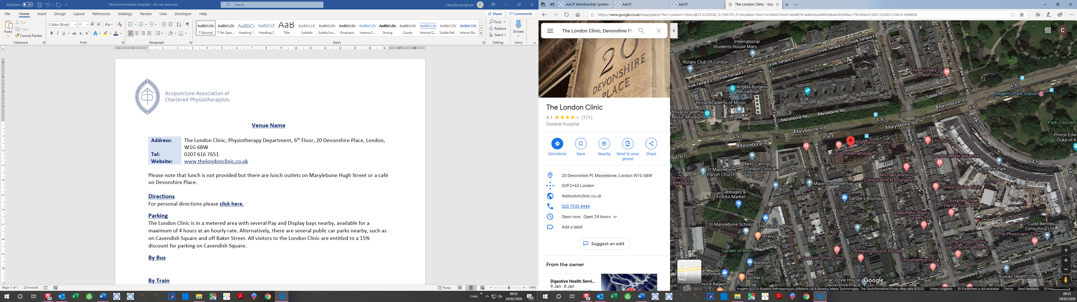

**Directions**

For personal directions please [**click here.**](https://www.google.co.uk/maps/dir/52.5787033,-0.2089822/The+London+Clinic,+20+Devonshire+Pl,+Marylebone,+London+W1G+6BW/@52.0497821,-0.7718458,9z/data=!3m1!4b1!4m16!1m6!3m5!1s0x48761ad0e2ea3e69:0xbda282806ec17b7e!2sThe+London+Clinic!8m2!3d51.522875!4d-0.150225!4m8!1m1!4e1!1m5!1m1!1s0x48761ad0e2ea3e69:0xbda282806ec17b7e!2m2!1d-0.150225!2d51.522875)

**Parking**

The London Clinic is in a metered area with several Pay and Display bays nearby, available for a maximum of 4 hours at an hourly rate. Alternatively, there are several public car parks nearby, such as on Cavendish Square and off Baker Street. All visitors to the London Clinic are entitled to a 15% discount for parking on Cavendish Square.

**By Bus**

The nearest bus stop to the clinic is Harley Street (Stop L). Please click on the below bus numbers to access their routes and timetables.

[Bus No. 18](https://tfl.gov.uk/bus/route/18/)

[Bus No. 27](https://tfl.gov.uk/bus/route/27/)

[Bus No. 205](https://tfl.gov.uk/bus/route/205/)

[Bus No. 453](https://tfl.gov.uk/bus/route/453/)

[Bus No. N18](https://tfl.gov.uk/bus/route/N18)

[Bus No. N27](https://tfl.gov.uk/bus/route/N27)

[Bus No. N205](https://tfl.gov.uk/bus/route/N205)

**By Train**

The nearest tube stations to the venue are Regents Park Station (approx. 4 minutes’ walk) or Baker Street Station (approx. 6 minutes’ walk).

For more information on train times or to book your travel, please [click here](https://tfl.gov.uk/)

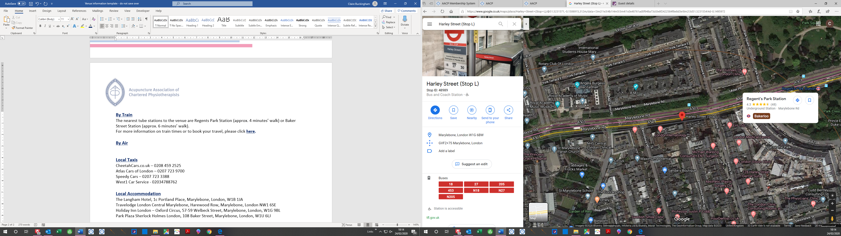

**By Air**

[London Heathrow Airport](https://www.heathrow.com/) – The London Clinic

**By Car:** 16.5 miles / 40 minutes

**By Train:** 1 hour via Bakerloo and Piccadilly

[Click here](https://www.google.co.uk/maps/dir/The+London+Clinic,+Devonshire+Place,+London/Heathrow+Airport+(LHR),+Longford+TW6/@51.4951218,-0.3642115,19989m/data=!3m2!1e3!4b1!4m13!4m12!1m5!1m1!1s0x48761ad0e2ea3e69:0xbda282806ec17b7e!2m2!1d-0.1498656!2d51.5230212!1m5!1m1!1s0x48767234cdc56de9:0x8fe7535543f64167!2m2!1d-0.4542955!2d51.4700223) for directions

[Gatwick Airport](https://www.gatwickairport.com/) – The London Clinic

**By Car:** 39.9 miles / 1hr 25 minutes

**By Train:** 50 minutes via Bakerloo, Victoria, Gatwick Express and Southern

[Click here](https://www.google.co.uk/maps/dir/The+London+Clinic,+Devonshire+Place,+London/Gatwick+Airport+(LGW),+Horley,+Gatwick+RH6+0NP/@51.3393369,-0.4890132,80227m/data=!3m2!1e3!4b1!4m13!4m12!1m5!1m1!1s0x48761ad0e2ea3e69:0xbda282806ec17b7e!2m2!1d-0.1498656!2d51.5230212!1m5!1m1!1s0x4875efde7d1f391b:0x59dda4bf018973ff!2m2!1d-0.1820629!2d51.1536621) for directions

[London Stansted Airport](https://www.stanstedairport.com/) – The London Clinic

**By Car:** 36.3 miles / 1 hour 19 minutes

**By Train:** 1 hour via Stansted Express and Metropolitan or Stansted Express

[Click here](https://www.google.co.uk/maps/dir/London+Stansted+Airport+(STN),+Bassingbourn+Rd,+Stansted+CM24+1QW/The+London+Clinic,+Devonshire+Place,+London/@51.7102749,-0.2249395,79576m/data=!3m2!1e3!4b1!4m13!4m12!1m5!1m1!1s0x487604b8a52a1bb7:0x30a4d0976b352648!2m2!1d0.2388661!2d51.8860181!1m5!1m1!1s0x48761ad0e2ea3e69:0xbda282806ec17b7e!2m2!1d-0.1498656!2d51.5230212) for directions

[London City Airport](https://www.londoncityairport.com/) – The London Clinic

**By Car:** 11 miles / 54 minutes

**By Train:** 45 minutes via Bakerloo, Central and DLR

[Click here](https://www.google.co.uk/maps/dir/The+London+Clinic,+Devonshire+Place,+London/London+City+Airport+(LCY),+Hartmann+Rd,+Royal+Docks,+London+E16+2PX/@51.5165026,-0.1204951,19979m/data=!3m2!1e3!4b1!4m13!4m12!1m5!1m1!1s0x48761ad0e2ea3e69:0xbda282806ec17b7e!2m2!1d-0.1498656!2d51.5230212!1m5!1m1!1s0x47d8a8880ebb3687:0x774e8a0a64b1a4b!2m2!1d0.049518!2d51.5048437) for directions

**Local Taxis**

CheetahCars.co.uk – 0208 459 2525

Atlas Cars of London – 0207 723 9700

Speedy Cars – 0207 723 3388

West1 Car Service - 02034788762

**Local Accommodation**

The Langham Hotel, 1c Portland Place, Marylebone, London, W1B 1JA

Travelodge London Central Marylebone, Harewood Row, Marylebone, London NW1 6SE

Holiday Inn London – Oxford Circus, 57-59 Welbeck Street, Marylebone, London, W1G 9BL

Park Plaza Sherlock Holmes London, 108 Baker Street, Marylebone, London, W1U 6LJ