**Leamington Rugby Football Club, Ultimate Physio**

|  |  |
| --- | --- |
| **Address:** | Leamington Rugby Football Club, Ultimate Physio, Leamington RFC, Moorefields, Kenilworth Road, Leamington Spa, CV32 6RG |
| **Tel:** | 07730 565 150 |
| **Website:** | <http://www.ultimatephysio.net/leamington-spa/> |

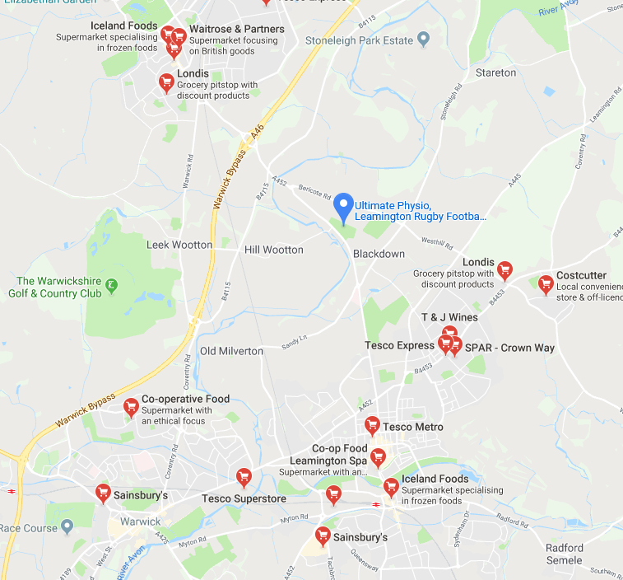

Please note that lunch is **not** provided, however the following places are close by;

* Tesco Metro, 22-24 Parade, Leamington Spa, CV32 4DN – 2.2 miles / 7-minute drive
* Tesco Express, Cubbington Road, Leamington Spa, CV32 7AH – 2.3 miles / 6-minute drive
* Sainsbury’s, 60-66 Warwick Road, Kenilworth, CV8 1HH – 2.2 miles / 6-minute drive

**Directions**

**By Car**

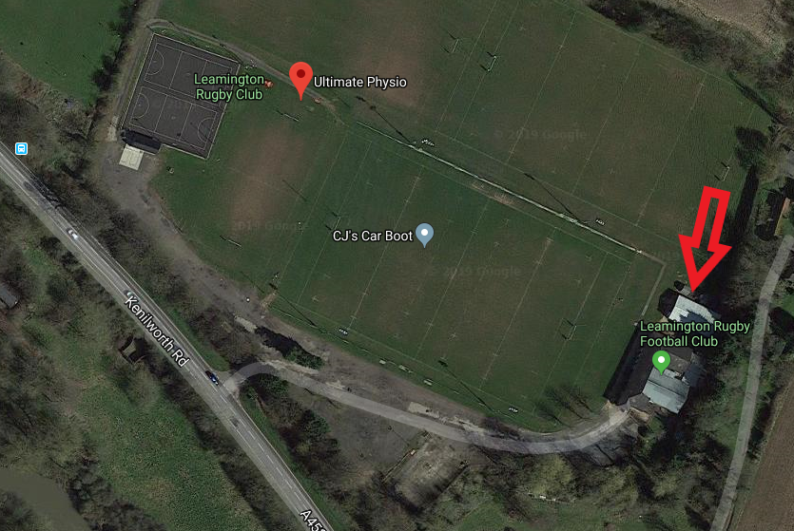Situated along the busy Kenilworth Road directly between both Kenilworth and Leamington Spa we are very easy to find from all surrounding areas. Our clinic is based directly at Leamington Spa Rugby Club, which boasts ample parking facilities and a fantastic environment for treatment. When arriving at the club if you head directly to your right up to the main clubhouse you will see a smaller building behind it where we are, and you will see the Ultimate Physio sign on this building. If you enter here our clinic is directly along the corridor in front of you with a seating area just outside the door.

By car we are directly on the main A452 Kenilworth Road, easily accessed via the A46 Warwick bypass and with close links to the M40 motorway. Leamington Rugby club is signposted along the main Kenilworth Road.

[**Click here**](https://www.google.co.uk/maps/dir/Ultimate+Physio,+Leamington+Rugby+Football+Club,+Kenilworth+Rd,+Blackdown,+Leamington+Spa+CV32+6RG/@52.3192689,-1.5420469,296m/data=!3m1!1e3!4m9!4m8!1m0!1m5!1m1!1s0x48773517861c2c8d:0x78f0544ba8f7d79!2m2!1d-1.542604!2d52.319636!3e0)for personal directions.

**By Train**

The closest railway station to the venue is Leamington Spa, Old Warwick Road, Leamington Spa, Warwickshire, CV31 3NS.

The railway is 3.7 miles and takes approximately 10 minutes in a taxi.

On average a taxi would cost £9.00 per way.

**By Bus**

There is a bus stop directly opposite the rugby club offering multiple services to Kenilworth, Leamington Spa, Coventry and Warwick. Leamington Spa train station is also just a sort journey away.

Stagecoach buses operate in this area, and X17, X18 and 11 stops outside the Rugby Club on Blackdown Road, Leamington Spa.

**By Air**

***Birmingham Airport (BHX) to Leamington Spa***

**By Car:** 25.6 miles (35 mins via M42 & M40)

**By Train:** 22 minutes via Cross Country Trains

***East Midlands Airport (EMA) to Leamington Spa***

**By Car:** 48.7 miles (56 minutes via M1 and M69)

**By Train:** 2h 39 minutes via Skyline and Cross Country Trains

***Nottingham Airport (NQT) to Leamington Spa***

**By Car:** 57.9 miles (1h 9 minutes via M69 and A46)

**By Train:** 2h 45 minutes via East Midlands Trains / Cross Country Trains / West Midland Trains

***London Luton Airport to Leamington Spa***

**By Car:** 68.7 miles (1h 25 minutes via M1)

**By Bus / Train:** 2h 31 minutes via National Express / Chiltern Railways

***London Heathrow to Leamington Spa***

**By Car:** 101 miles (1h 56 minutes via M40 and A425)

**By Bus / Train:** 2h 10 minutes via number 90 bus to Northolt / GWR to Reading / Cross Country Trains to Manchester Piccadilly via Coventry and Stoke on Trent

**Local Accommodation**

* Premier Inn Leamington Spa Town Centre Hotel, 154-156 Parade, Leamington Spa, CV32 4BQ
* Travelodge, The Regent Hotel Leamington Spa, The Parade, Leamington Spa, Warwickshire, CV32 4AT
* Holliday Inn Leamington Spa, Olympus Avenue, Tachbrook Park, Royal Leamington Spa, Leamington Spa, CV34 6RJ
* Best Western Falstaff Hotel, 16-20 Warwick New Road, Leamington Spa, CV32 5JQ

**Local Taxi Companies**

* Easy Cabs – 01926 425 959
* Leamington Taxis – 01926 888 118
* Taxi Leamington Spa – 01926 801 901
* Sapphire Taxis – 01926 881 313