Directions
Address: English National Ballet, Mulryan Centre of Dance, Multipurpose/Medical Room, 41 Hopewell Street, London, E14 0SY
Website Address: www.ballet.org.uk
There is a kitchen for morning and afternoon tea; a café downstairs and a Sainsburys Local next door.
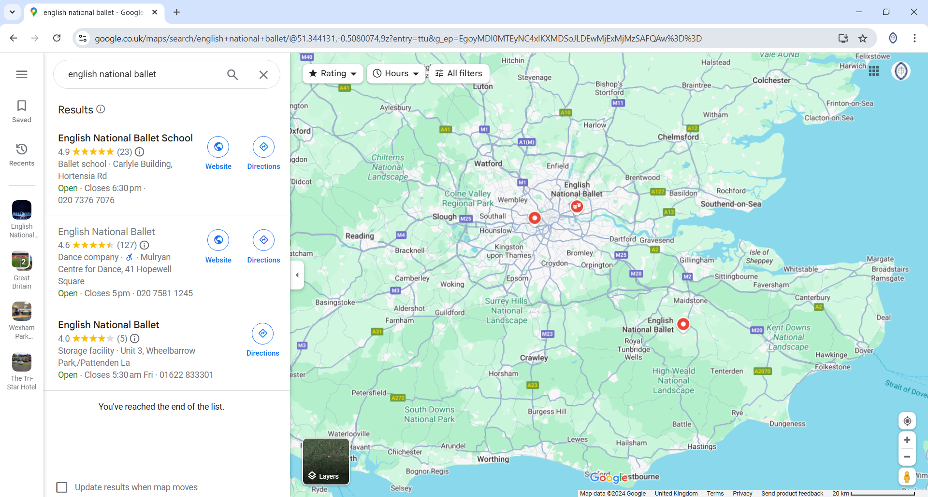

The Mulryan Centre for Dance is easily accessible by car, bicycle or via public transport.
By Underground/DLR
Canning Town station: Jubilee Line & DLR, 5 minute walk
The Mulryan Centre for Dance is on London City Island, a short walk from Canning Town station. Exit the barriers and turn left towards the Bow Creek exit, taking the lift or stairs to street level. Then cross the red bridge onto London City Island and the Mulryan Centre for Dance is directly ahead of you.
By Bike
Cycle Superhighway (Hyde Park to Barking) passes close by and is around a 2 minute cycle from the Mulryan Centre for Dance. There are multiple bike racks around the Island.
The nearest Santander cycle docking station is by East India station (DLR), 14 minute walk.
By Bus
Routes 5, 69, 115, 147, 241, 300, 309, 323, 330 stop at Canning Town Bus Station.
Route D3 stops at Leamouth/Orchard Place.
By Car
The Mulryan Centre for Dance is outside of the Congestion Charge Zone, but within the ULEZ and LEZ Zones.
Cars can drop off or wait for guests for up to 20 minutes on the Island. For any longer period a permit for the Car Park needs to be purchased from the London City Island Concierge, at the front of Kent Building, in the centre of the Island. The Car Park is located at the rear of the Mulryan Centre for Dance. Only Blue Badge holders or oversized vehicles can park in the exterior parking spaces, all other vehicles need to park in the Car Park.

