Directions
Address: Lyfe Health Bournemouth, 106-108 Poole Road, Westbourne, Bournemouth, BH4 9EQ
Telephone Number: 01202 119221
Website Address: www.lyfehealth.co.uk

There is a small staff room with a small fridge, sink and kettle. There is a café on site fir tea, coffee and snacks.
They are situated on a main high street with multiple cafe’s and restaurants. Supermarkets are within 1 minute walking distance.
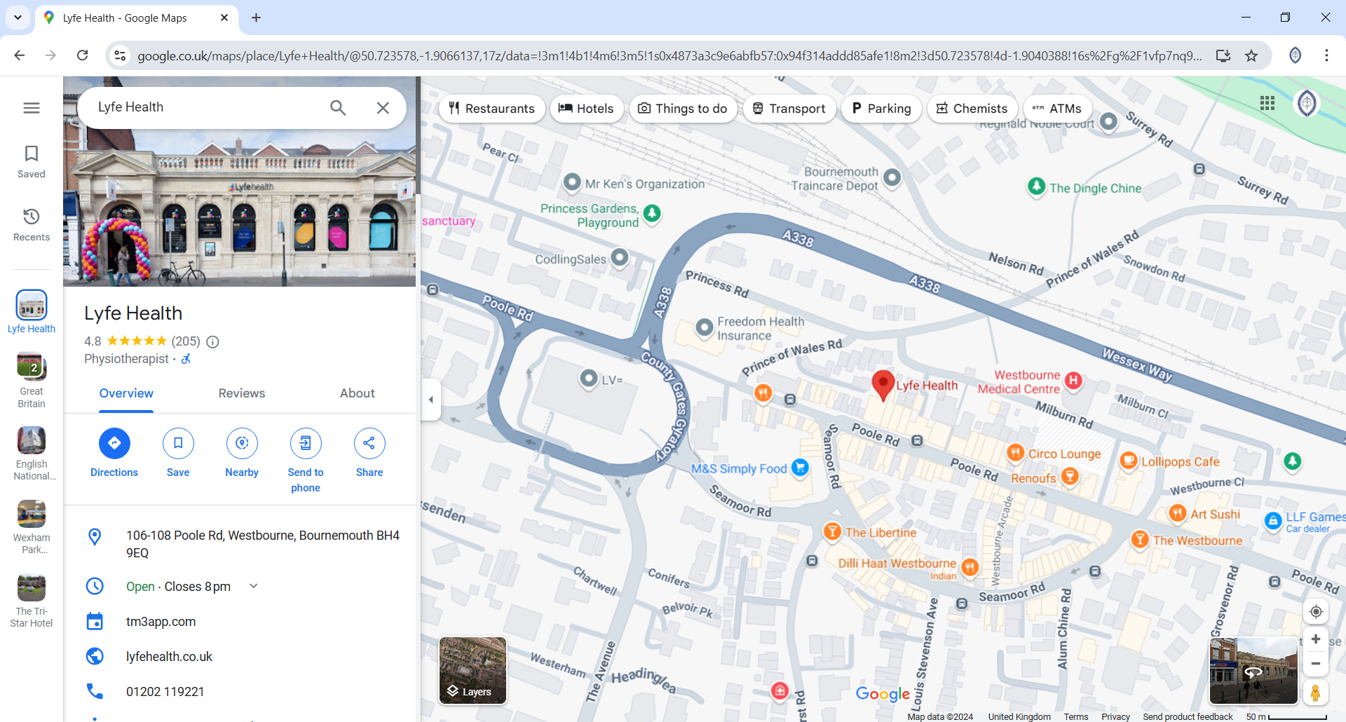

There is a small first come first serve basis car park at the rear of the building (10 spaces).
There is a council pay & display car park adjacent to the car park on Milburn Road.

