**Vita Health, Crystal Palace Sports Injuries Clinic, London**

|  |  |
| --- | --- |
| **Address:** | Vita Health Group, Crystal Palace Sports Injuries Clinic, Jubilee Stand, Crystal Palace Park, London, SE19 2BB |
| **Tel:** | 0208 778 9050 |
| **Website:** | [www.vitahealthgroup.co.uk](http://www.vitahealthgroup.co.uk) |

Please note that lunch is not provided but there is a kitchen onsite and a selection of cafes and shops nearby.

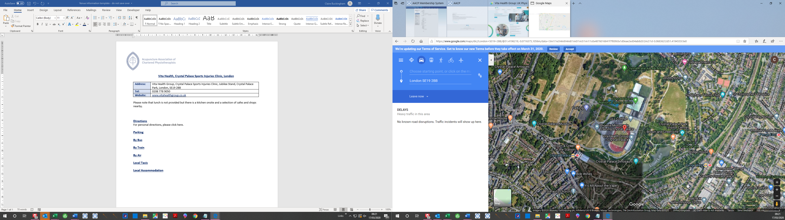

**Directions**

The Crystal Palace physiotherapy clinic and sports injury centre is conveniently located within the Crystal Palace Park. As you enter the park from Anerley Hill take your first right and continue straight down through the mini roundabout. This leads onto the road behind the Jubilee Stand (the athletics track will be on your left). Follow the signs to the Jubilee Stand. Please note we are not located in the Main Building.

For personal directions, please [click here](https://www.google.com/maps/dir/London+SE19+2BB/@51.4181634,-0.071144,1056m/data=!3m1!1e3!4m9!4m8!1m0!1m5!1m1!1s0x4876016841f7f009:0x1d0eae2ed04ab8d3!2m2!1d-0.068362!2d51.4194555!3e0).

**Parking**

There is dedicated off-street parking outside the Centre and ample of additional parking directly adjacent to the Jubilee Stand.

**By Bus**

Crystal Palace has a main bus terminus at the top of the hill. It is a 15-minute walk to the Centre and is serviced by numerous bus routes including the 3, 122, 157, 202, 227, 249, 322, 358, 363, 410, 417, 432, 450, 931

**By Train**

Crystal Palace is a short 5-10 minute’ walk from the Centre. Turn right out of the station and make your way into the park. Turn right down the circuit road and follow the signs to the Jubilee Stand.

**By Underground**

Crystal Palace Overground arrives at the British Rail Station and the directions are the same as above.

**By Air**

The closest airport to the venue is Heathrow Airport, which is approx. 1 hour 15 minutes’ drive or 1 hour 30 minutes on the underground.

Please [click here](https://www.google.co.uk/maps/dir/Heathrow+Airport,+Longford/London+SE19+2BB/@51.4093594,-0.444149,11z/data=!3m1!4b1!4m14!4m13!1m5!1m1!1s0x48767234cdc56de9:0x8fe7535543f64167!2m2!1d-0.4542955!2d51.4700223!1m5!1m1!1s0x4876016841f7f009:0x1d0eae2ed04ab8d3!2m2!1d-0.068362!2d51.4194555!3e0) for further details.

**Local Taxis**

* Crystal Cars – 0208 768 1111
* Station Cars London – 0208 778 7878
* Crystal Palace Cars – 0208 771 5088
* Crystal Palace Airport Transfers – 0208 659 9000

**Local Accommodation**

* Travelodge London Crystal Palace, 61-63 Croydon Road, Penge, SE20 7TS
* London Crystal Palace Queens Hotel. 122 Church Road, London, Crystal Palace, London, SE19 2UG
* IBIS Styles London Croydon, 585-589 London Road, Thornton Heath, London, CR7 6AY
* Crystal Palace Croydon (Purley A23), The Colonnades Leisure Park, 619 Purley Way, Surrey, CR0 4RQ