Directions

Address: Frimley Health NHS Foundation Trust, Wexham Park Hospital, Therapies Department – Physiotherapy, Wexham Street, Slough, Berkshire, SL2 4HL
Telephone No: 0300 614 5000
Website Address: fhft.nhs.uk

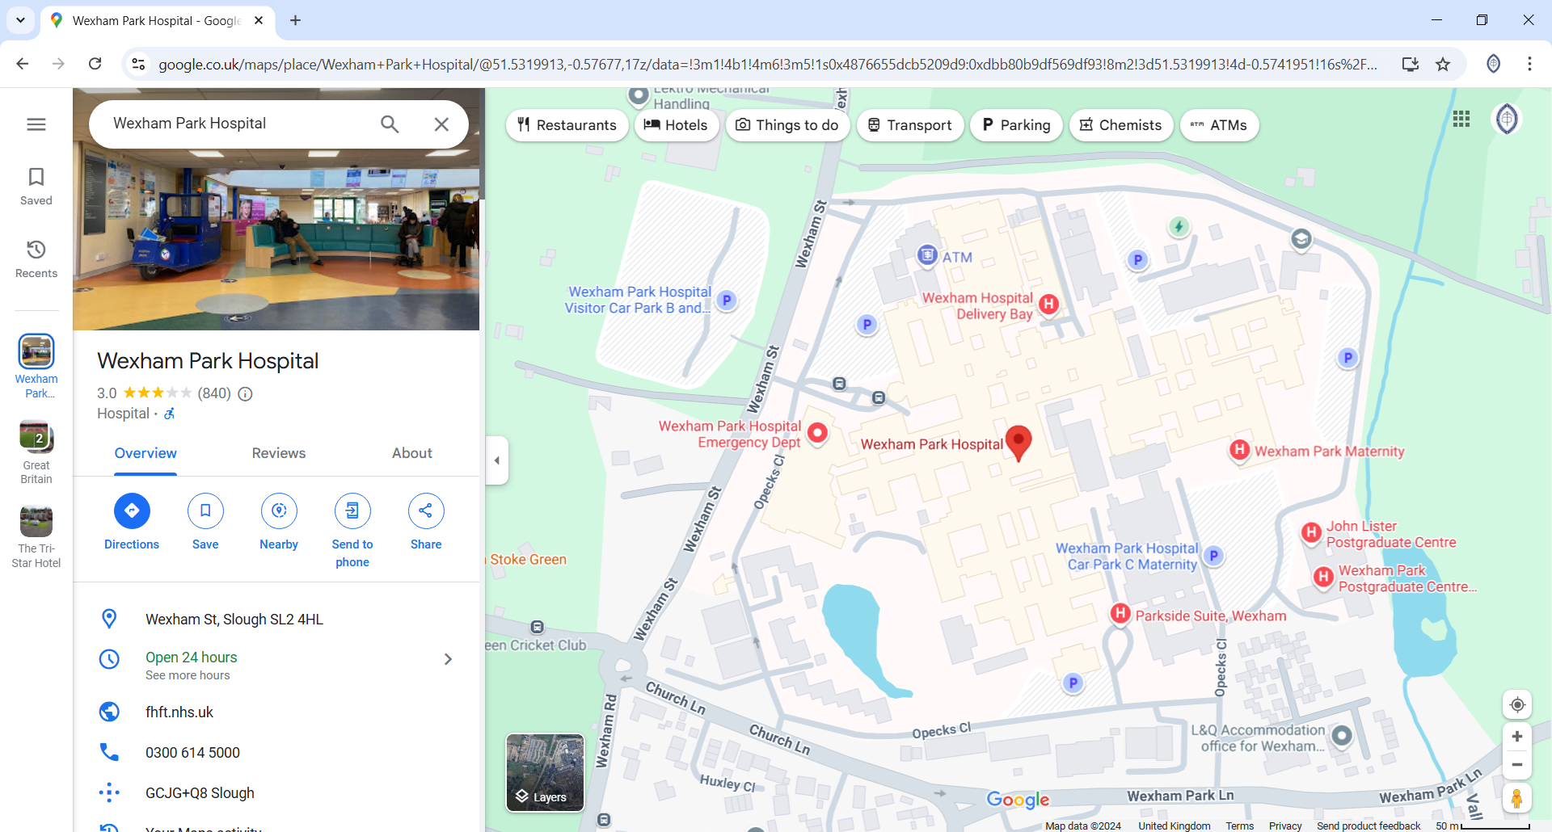

By Car
You can get to the hospital
Via the M4 - closest junction 5
Via the M25 - closest junctions 15 and 16
Via the M40 - closest junction 2
For sat nav use post code SL2 4HL

By Bus
The hospital is serviced by two local bus operators, First Berkshire and Thames Valley Network and Redline. Both pick up and set down passengers at a dedicated bus stop in the hospital directly adjacent to the main entrance.
Bus services that stop at the hospital travel to/from a number of destinations in the local area, including Slough, Maidenhead, Bracknell and the Chalfonts.
By Train
The nearest railway station is Slough, which is part of the National Rail network operated by GWR.
Trains to/from the station provide frequent and efficient services between many destinations, including London Paddington, Windsor and Eton Central, Maidenhead, Reading, and Oxford.
Options for travelling to the hospital from the train station are:
- By bus, on the WP1, 6/6a or 335 from Slough bus station
- Taxi rank adjacent to the station entrance on Brunel Way.
Please allow between 5 to 10 minutes travel time by taxi and 20 minutes by bus in order to reach the hospital. Bus services may take up to 30 minutes during peak times due to traffic congestion.

Parking facilities for patients and visitors are available in two car parks (A and B) at the front of the hospital, accessed via gate 2 on Wexham Street, and one car park (C) for maternity and day surgery patients accessed via gate 4 on Wexham Park Lane.
A 'pay on foot' system operates for parking so you'll need to remember to take your parking ticket with you and pay before returning to your vehicle.
Pay machines are located:
- Outside the main entrance
- Outside and adjacent to the emergency department
- Inside the maternity entrance
Payment can be made in cash or by card.
Parking charges
Parking charges from Monday 3 June 2024
Up to 20 minutes - free
20 minutes to 2 hours - £4.00
2 to 3 hours - £5.50
3 to 4 hours - £6.50
4 to 5 hours - £7.50
Over 5 hours - £8.50
7 day ticket - £18.00
30 day pass - £55

