Directions

Address: Nuffield Health Cheltenham Hospital, Physiotherapy Department, Hatherley Lane, Cheltenham, GL51 6SY
Telephone: 01242 246503
Website: https://www.nuffieldhealth.com/hospitals/cheltenham

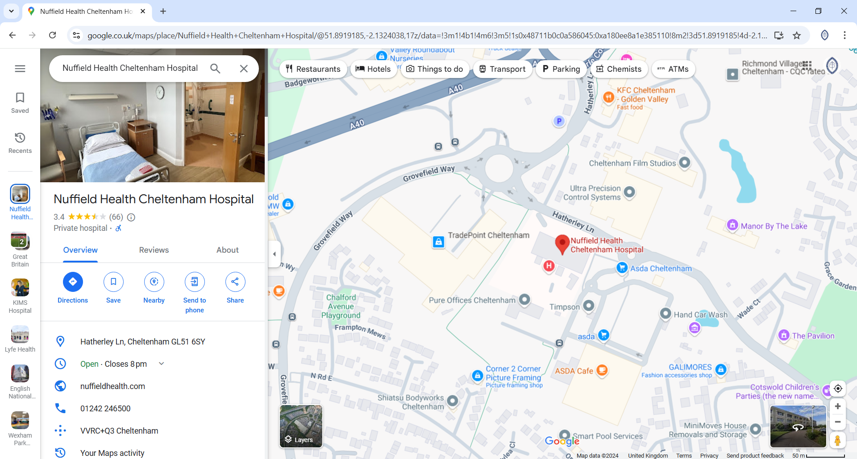

We have free parking in the hospital. You don’t need to register your number plate just park around the side/back of the hospital and come into reception at the front.

