Directions

Address: Weardale Physiotherapy & Sports Injury Clinic, 9 Front Street, Wolsingham, County Durham, DL13 3DF
Telephone Number: 01388 527878
Website: weardalephysiotherapy.co.uk
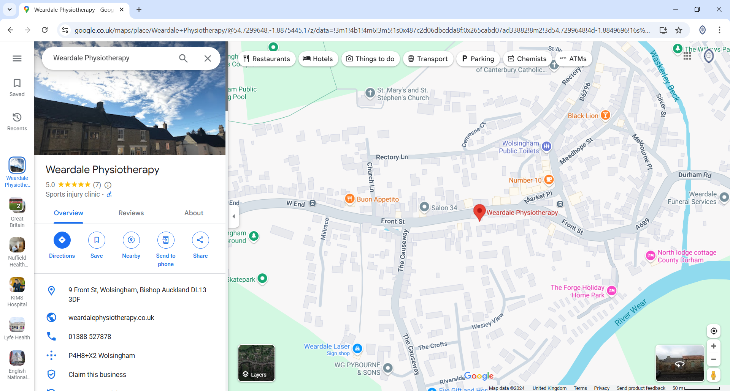

- There are no parking facilities available - parking is available on the street.
- There is a small kitchenette with a kettle. There are 2 cafes and 2 corner shops in the village.

