**Herbprime.co.ltd, Manchester**

|  |  |
| --- | --- |
| **Address:** | Herbprime.co.ltd, Unit 2 Fourways Trading Estate, Longbridge Road, Trafford Park, Manchester, M17 1SW |
| **Tel:** | 0800 310 1588 |
| **Website:** | [www.herbprime.com](http://www.herbprime.com/) |

Please note that lunch is not provided but there is an Asda Supercentre approx. 6 minutes drive from the venue.

Directions to Asda Trafford Park Supercentre, Barton Dock Roadm Stretford, Manchester, M41 7ZA

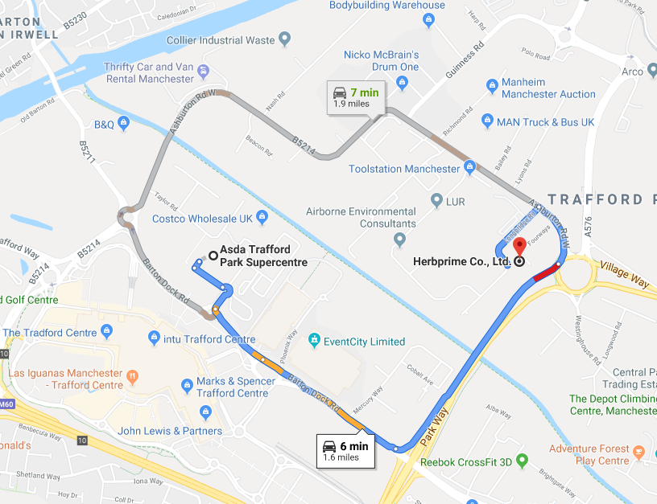

**Directions**

Please [**click here**](https://www.google.co.uk/maps/dir/Herbprime+Co.,+Ltd.,+Fourways+Trading+Estate,+Longbridge+Rd,+Stretford,+Manchester+M17+1SW/@53.4676995,-2.3313271,17z/data=!4m16!1m6!3m5!1s0x487bae6a6f0ea981:0x3e14d37f09342f14!2sHerbprime+Co.,+Ltd.!8m2!3d53.4687528!4d-2.3286248!4m8!1m0!1m5!1m1!1s0x487bae6a6f0ea981:0x3e14d37f09342f14!2m2!1d-2.3286248!2d53.4687528!3e2) for personal directions.

**Parking**

Free Parking is available onsite.

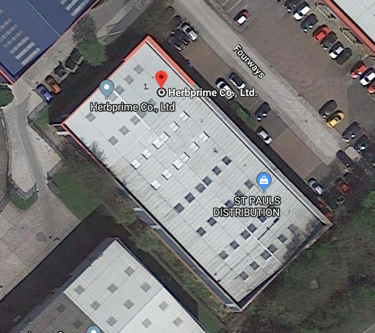

**Travelling by Train**

The closest railway station to the venue is Trafford Park Railway, which is approx. 7 minutes taxi ride to the venue.

For more information on train times or to book your travel, please click [**here**](http://www.nationalrail.co.uk/)**.**

**Taxi Companies**

* Radio Cars – 0161 236 8033
* Union Cars – 0161 225 5566
* Link Cars – 0161 225 1800

**Travelling by Bus**

Park Way is the nearest bus stop on the No. 272 and is a 5 minute walk to the venue.

To plan your journey, please [**click here**](https://my.tfgm.com/#/planner/).

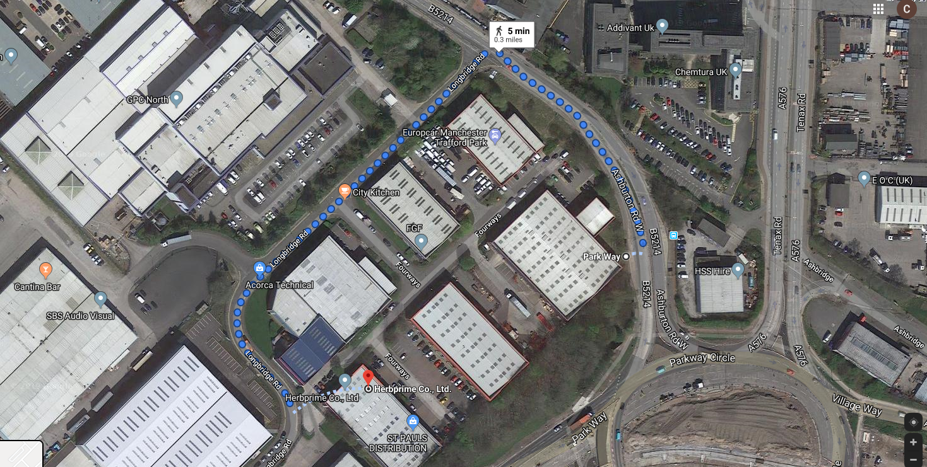

**Travelling by Tram**

Ladywell Tram (Stop A) (Eccles New Road, M5 5AT) is the nearest stop and will take 7 minutes in a taxi or 36 minutes to walk to the venue.

To plan your journey, please [**click here**](https://my.tfgm.com/#/planner/).

Please see see below the tram map for your information.

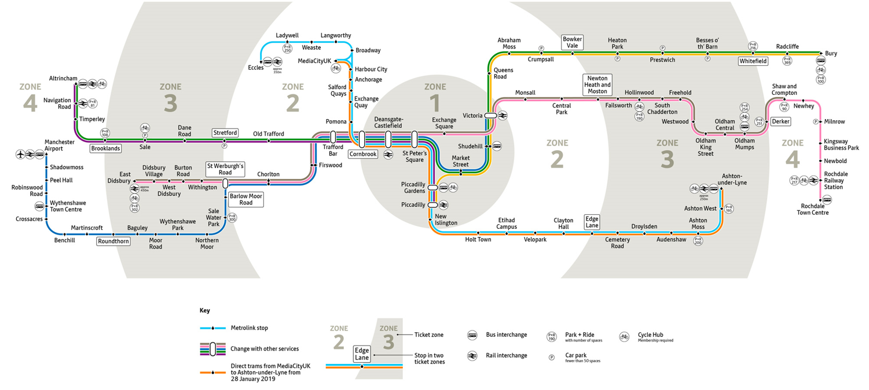

**Travelling by Air**

Manchester Airport is the nearest airport to the venue, for flight times please click here.

**Directions from Airport**

**By Taxi:**

* Via M56 – 31 minutes / 10.1 miles
* Via M56 & M60 – 33 minutes / 10.8 miles
* Via M60 – 38 minutes / 11.2 minutes

[**Click here**](https://www.google.co.uk/maps/dir/Manchester+Airport,+Manchester+M90+5PH/Herbprime+Co.,+Ltd.,+Fourways+Trading+Estate,+Longbridge+Road,+Manchester/@53.4159826,-2.3733472,12z/data=!3m1!4b1!4m18!4m17!1m5!1m1!1s0x487a52cc0231bc39:0x4fd90b7b6a4a49d6!2m2!1d-2.2867082!2d53.3628488!1m5!1m1!1s0x487bae6a6f0ea981:0x3e14d37f09342f14!2m2!1d-2.3286248!2d53.4687528!2m3!6e1!7e2!8j1564259400!3e0) for more details

**Using Public Transport**

* From Cargo Centre (No. X30) – Victoria Tram (Navy Line) – Trafford Bar (No. 250 Intu Trafford Centre) – 1h 38mins
* From Cargo Centre (No. X30) – Manchester Airport (Transpennine Express to Edinburgh, Platform A) – Oxford Road Station (No. 250 Intu Trafford Centre) – 1h 28 mins
* From Cargo Centre (No.103, Piccadilly Gardens), Manchester Airport (Transfpennine Express via Middlesborough) – Oxford Road Station (Intu Trafford Centre) – Westinghouse Road – 1h 27 mins

[**Click here**](https://www.google.co.uk/maps/dir/Manchester+Airport,+Manchester+M90+5PH/Herbprime+Co.,+Ltd.,+Fourways+Trading+Estate,+Longbridge+Road,+Manchester/@53.4191752,-2.3441733,12z/data=!4m19!4m18!1m5!1m1!1s0x487a52cc0231bc39:0x4fd90b7b6a4a49d6!2m2!1d-2.2867082!2d53.3628488!1m5!1m1!1s0x487bae6a6f0ea981:0x3e14d37f09342f14!2m2!1d-2.3286248!2d53.4687528!2m3!6e1!7e2!8j1564259400!3e3!5i1) for more details

**Accommodation**

* Premier Inn Manchester City (Piccadilly) Hotel, 72 Dale Street, Manchester, M1 2HR
* Travelodge Manchester Upper Brook Street Hotel, 227 Upper Brook Street, Manchester, M13 0HB
* DoubleTree by Hilton Manchester Piccadilly Hotel, One Piccadilly Place, Manchester City Centre, Manchester, M1 3DG
* Holiday Inn Manchester City Centre, 29 Aytoun Street, Manchester City Centre, Manchester, M1 3DT

For a list of hotel price comparisons, please [**click here**](https://www.booking.com/index.en-gb.html?label=gen173nr-1BCAEoggI46AdIM1gEaFCIAQGYAQm4ARfIARTYAQHoAQGIAgGoAgO4AprEt-kFwAIB;sid=4809a70e99b06d3810e7ce34cceb4bfb;keep_landing=1&sb_price_type=total&)