Queen Mary’s Hospital, London

Address: | Queen Mary’s Hospital, Suite 6, Ground Floor, Roehampton Lane, London, SW15 5PN
Tel: | 0208 487 6022/0208 487 6054
Website: | www.stgeorges.nhs.uk

Please note that lunch is not provided.
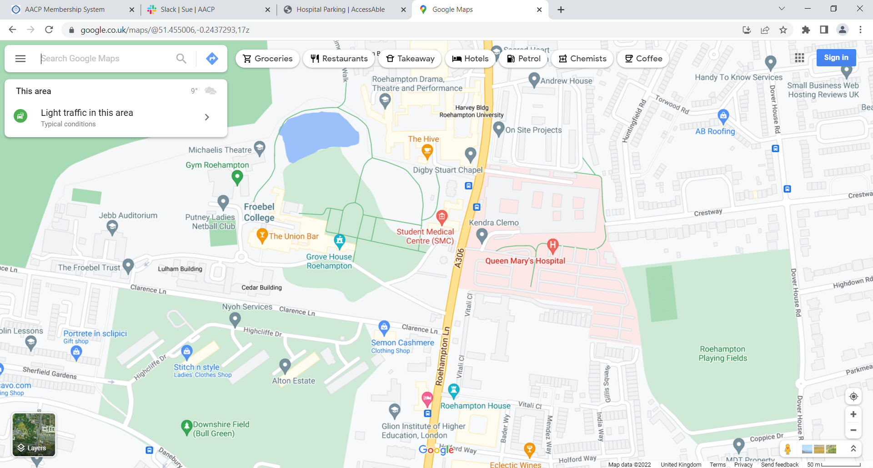

By Road

- Queen Mary's Road is located on Roehampton Lane/A306 and can be accessed via the A205.
Head east on Upper Richmond Road/A205 towards Rock Lane.
Turn right onto Roehampton Lane/A306 and Queen Mary's Hospital will be located on the left after 0.7 miles.
- Queen Mary's Hospital has one main visitors car park and multiple Blue Badge bays by the lower ground entrance.
By Bus

- Bus routes 72, 265, 493, 969 and N74 stop directly outside Queen Mary's Hospital on Roehampton Lane.
.
- There is an onsite bus stop.
- Onsite bus stops are located on the main hospital road.
- The main onsite bus stop is sheltered with bench seating.
- The hospitals main entrance is approximately 140m from the onsite bus stop.
The path leading to the hospital from the bus stop is on a slight slope and is slab paving.
After turning into the hospital, there is one road to cross with tactile paving on both sides.
After, there is another slight slope, with slab paving leading to the main hospital entrance.

By Train

- The nearest train station is Barnes Station, which is approximately 1.1 miles from Queen Mary's Hospital.

By Underground

- The nearest underground station is East Putney station, which is approximately 2.2 miles from Queen Mary's Hospital.

- For detailed information on Barnes Station please follow the link.
- To view the web page described above click here (opens in new tab).
- For detailed information on East Putney Underground Station please follow the link.
- To view the web page described above click here (opens in new tab).
Parking

- The hospital does have a dedicated car park.
- The car park is located in front of the hospital.
- The car park type is open air/surface.
- The car park does not have a height restriction barrier.
- The car park does have a barrier control system.
- There is a touchscreen at the barrier.
- The barrier controls/touchscreen can be reached from the car.
- The car park surface is tarmac.
- There is a/are clearly marked/signposted Blue Badge parking bay(s) available.
- The Blue Badge bay(s) is/are clearly marked.
- There is/are 10+ designated Blue Badge parking bay(s) within the hospital car park.
- The dimensions of the designated Blue Badge parking bay(s) surveyed are 365cm x 480cm.
- There is not a 120cm hatched zone around the Blue Badge parking bay(s).
- Parking spaces for Blue Badge holders do not need to be booked in advance.
- There are parking charges for the hospital car park.
- Payment signs are provided.
- Payment signs are clearly presented.
- Payment signs are located at the payment machines in the car park.
- Payment signs do not make it clear if parking charges apply to Blue Badge holders.
- Parking is free for Blue Badge holders.
- Payment machines are located outside the main entrance.
- There is not a payment machine at a convenient height for wheelchair users.
- There is a level turning space (minimum 185cm x 210cm) in front of the payment machine(s).

