The London Clinic, London

Address: | The London Clinic, Physiotherapy Department, 6th Floor, 20 Devonshire Place, London, W1G 6BW
Tel: | 0207 616 7651
Website: | www.thelondonclinic.co.uk

Please note that lunch is not provided but there are lunch outlets on Marylebone Hugh Street or a café on Devonshire Place.

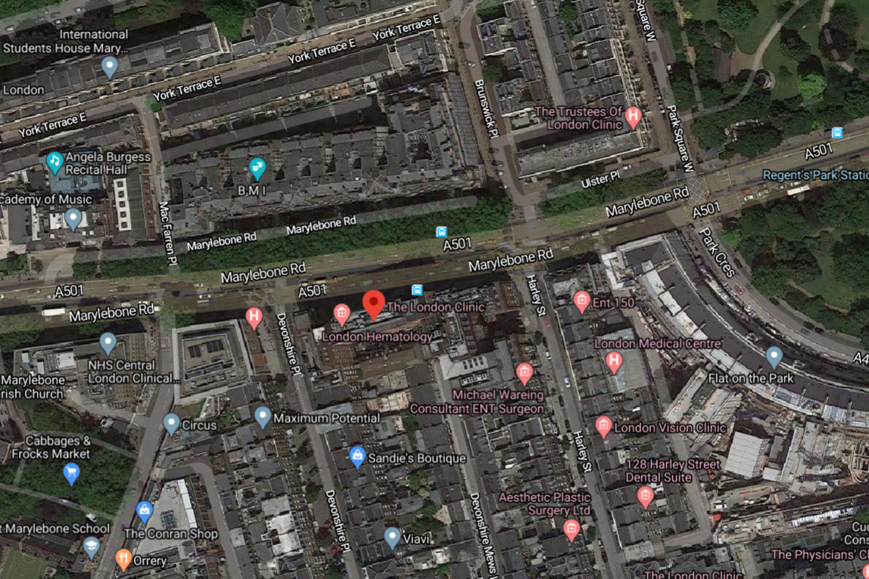

Directions
For personal directions please click here.
Parking
The London Clinic is in a metered area with several Pay and Display bays nearby, available for a maximum of 4 hours at an hourly rate. Alternatively, there are several public car parks nearby, such as on Cavendish Square and off Baker Street. All visitors to the London Clinic are entitled to a 15% discount for parking on Cavendish Square.
By Bus
The nearest bus stop to the clinic is Harley Street (Stop L). Please click on the below bus numbers to access their routes and timetables.
Bus No. 18
Bus No. 27
Bus No. 205
Bus No. 453
Bus No. N18
Bus No. N27
Bus No. N205

By Train
The nearest tube stations to the venue are Regents Park Station (approx. 4 minutes’ walk) or Baker Street Station (approx. 6 minutes’ walk).
For more information on train times or to book your travel, please click here

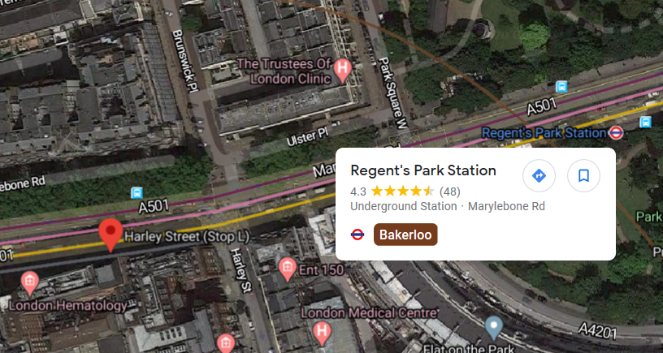

By Air
London Heathrow Airport – The London Clinic
By Car: 16.5 miles / 40 minutes
By Train: 1 hour via Bakerloo and Piccadilly
Click here for directions

Gatwick Airport – The London Clinic
By Car: 39.9 miles / 1hr 25 minutes
By Train: 50 minutes via Bakerloo, Victoria, Gatwick Express and Southern
Click here for directions

London Stansted Airport – The London Clinic
By Car: 36.3 miles / 1 hour 19 minutes
By Train: 1 hour via Stansted Express and Metropolitan or Stansted Express
Click here for directions

London City Airport – The London Clinic
By Car: 11 miles / 54 minutes
By Train: 45 minutes via Bakerloo, Central and DLR
Click here for directions

Local Taxis
CheetahCars.co.uk – 0208 459 2525
Atlas Cars of London – 0207 723 9700
Speedy Cars – 0207 723 3388
West1 Car Service - 02034788762

Local Accommodation
The Langham Hotel, 1c Portland Place, Marylebone, London, W1B 1JA
Travelodge London Central Marylebone, Harewood Row, Marylebone, London NW1 6SE
Holiday Inn London – Oxford Circus, 57-59 Welbeck Street, Marylebone, London, W1G 9BL
Park Plaza Sherlock Holmes London, 108 Baker Street, Marylebone, London, W1U 6LJ

